## [Image result for aquinas school](https://en.wikipedia.org/wiki/Aquinas_Diocesan_Grammar_School)

Sentinus Team R&D 2019-2020

Aquinas Grammar School

Purge Point Access Tool

[](http://www.google.co.uk/url?sa=i&rct=j&q=&esrc=s&source=images&cd=&cad=rja&uact=8&ved=2ahUKEwiR64S-vsHmAhUmUBUIHXgaC7QQjRx6BAgBEAQ&url=http://phoenixgroupni.co.uk/about-the-phoenix-group/company-information&psig=AOvVaw1n1EvvQMSwXCRR5yhMMdMG&ust=1576837203829607)

In Partnership with Phoenix Natural Gas.

**Team Members**

Andrew Farquharson

Georgia Montgomery

Joseph McSorley

Laoise Kielty

Olivia Morrow

Table of Contents

1

Introduction 3

Acknowledgments 3

About our Partner Company 4

Introduction to the School 5

Introduction to the Team 6

Research 7

Design Brief and Current Solution 7

Trip to Phoenix 8

Initial Ideas 9

Initial Idea One 9

Initial Idea Two 10

Initial Idea three 11

Agreed Solution 12

Modelling 13

Metal Model 14

Inital Testing 16

Changes from Testing 17

Design of Adjustable Solution 18

Adjustable Valve Head Clamp 20

Adjustable Body Clamp 22

Stability Improvements 24

Miniaturisation 25

Wooden Model 26

Final Prototype 27

Bibliography 28

Acknowledgments

Firstly, we would like to thank our link engineer from Phoenix Natural Gas, Neil Preshaw. Throughout the programme, he equipped our team with vital information and resources which were very valuable when it came to solving our problem. Neil, and other members from Phoenix Gas, were essential in the process as they helped us to fully understand the gas network and therefore understand the purge points and their faults. His visits to our school and the site visits that he set up for us were essential in helping us envision the problem at hand, and coming up with ways to solve it.

We would also like to extend our thanks to all the staff members at Queens University, in particular, Dr Oana Istrate and Dr Richard Gault, for helping us identify the need for improvements in our design and thus making it possible to fabricate our project. Additionally, we would like to thank Sarah Rowland and David Pinkerton from Sentinus for allowing us to participate in this programme and for organising and inviting us to meetings and workshop days that our team found very useful.

Finally, we would like to thank our teachers Mr Duffy and Mrs O’Brien for their continued commitment and support for our Sentinus team R&D. Their invaluable knowledge and advice throughout the process helped us in developing our purge point project.

Phoenix Natural Gas

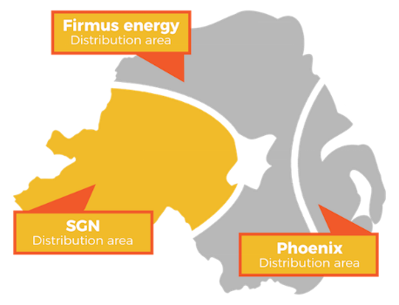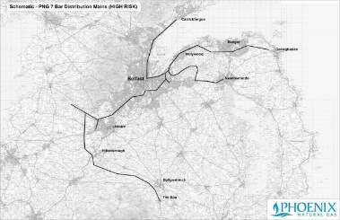

The gas distribution network comprises of around 3,800 kilometres of intermediate, medium and low-pressure mains which currently supplies gas to 220,000 households.

Phoenix Natural Gas is the largest gas distribution business in [Northern Ireland](https://en.wikipedia.org/wiki/Northern_Ireland), being the owner and operator of the licence for the distribution network in the [Greater Belfast](https://en.wikipedia.org/wiki/Belfast) area. It was founded in 1996, around the same time of the completion of the Scotland Northern Ireland Pipeline, commonly known as the SNIP. Phoenix Gas manages the development and construction of these pipelines; however, they are not responsible for the selling of gas to properties, solely the transport of the gas throughout Greater Belfast, Larne and East Down.

In December 2015 a license was approved for the extension of the Phoenix Gas network to 13 new towns in East Down including; Anahilt, Ballygowan, Ballynahinch, Castlewellan, Crossgar, Downpatrick, Dromore, Drumaness, Dundrum, Hillsborough, Newcastle, Saintfield and the Spa.This £60m investment by the company will see natural gas being made available to an additional 28,000 properties in Country Down. Construction commenced in early 2016 with Ballygowan being the first town to connect to the network.

Phoenix Gas now boasts over 218,000 customers, which it has gained over twenty years. It gains around 8,000 new customers each year and employs over 3,000 people.

Phoenix Gas is committed to reducing its carbon footprint. The use of natural gas that it provides has equated to 7.5 million tonnes less CO2 in the atmosphere.

Aquinas Grammar School

Aquinas Grammar School was established by the Diocese of Down and Connor as a co-educational voluntary Grammar School. It admitted the first 110 pupils in September 1993.

The school is situated on the Ravenhill Road in South-East Belfast. The school currently contains 100 members of staff led by the Principal Mr Barry Kelly, along with 800 students.

Aquinas has founded a strong focus on academia, particularly STEM-based subjects, and continues to promote them to students as an opportunity to develop their problem solving and mathematical skills, as well as their interests in Science and Technology, whilst also promoting interaction with fellow students through projects such as Sentinus.

Aquinas Grammar provides opportunities to study a wide range of STEM-based subjects such as Maths, Physics, Chemistry, Biology, Computer Science, Further Maths and Technology and Design for both GCSE and A-Level, along with a variety of extracurricular activities to promote a love of STEM from as young as their first year; with a Technology and Design club, the Grand Prix Team, Ecology club and Science/Maths mentoring. Children are also taught Science, Maths, ICT and Technology and Design from their first year at Aquinas; this allows them to be involved with the STEM subjects throughout all their years at Aquinas if they choose.

This is the 13th year that Aquinas has participated in the Sentinus R&D project and the 5th year in partnership with Phoenix Gas.



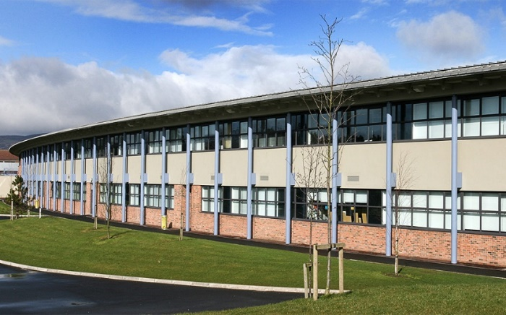

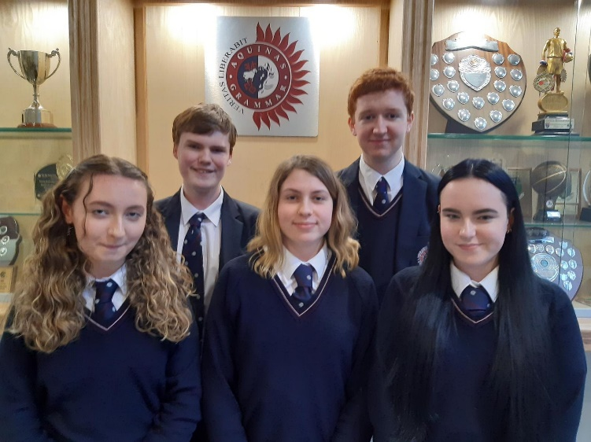The Team

**Laoise Kielty**

**Age:** 17 (31/08/2002)

**A-Level Subjects:** Mathematics, Further Mathematics, Physics and Chemistry.

**Plans for Future Career:** Environmental engineering or Physics.

**Joseph McSorley**

**Age:** 17 (14/11/2002)

**A-Level Subjects:** Mathematics, Physics, Chemistry, French.

**Plans for Future Career:** Aeronautical or Aerospace Engineering.

**Andrew Farquharson**

**Age:** 16 (24/04/2003)

**A-Level Subjects:** Mathematics, Further Mathematics, Physics, Chemistry and Technology and Design.

**Plans for Future Career:** Electrical Engineering or Mathematics.

**Olivia Morrow**

**Age:** 17 (26/09/2002)

**A-Level Subjects:** Mathematics, Chemistry, Technology and Design, and Food and Nutrition Science.

**Plans for Future Career:** Biomedical Engineering.

**Georgia Montgomery**

**Age:** 16 (20/06/2003)

**A-Level Subjects:** Mathematics, Physics and History.

**Plans for Future Career:** Architecture or Civil Engineering.

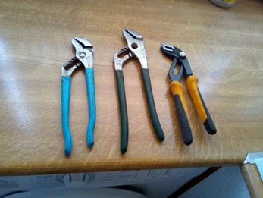[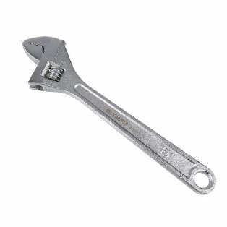](http://www.google.co.uk/url?sa=i&rct=j&q=&esrc=s&source=images&cd=&cad=rja&uact=8&ved=&url=/url?sa%3Di%26rct%3Dj%26q%3D%26esrc%3Ds%26source%3Dimages%26cd%3D%26ved%3D%26url%3Dhttps://www.amazon.co.uk/Olympia-01-015-15-Inch-Adjustable-Wrench/dp/B000VJNONU%26psig%3DAOvVaw2QsWTf0naBYotrVa88nyFa%26ust%3D1574264356700524&psig=AOvVaw2QsWTf0naBYotrVa88nyFa&ust=1574264356700524)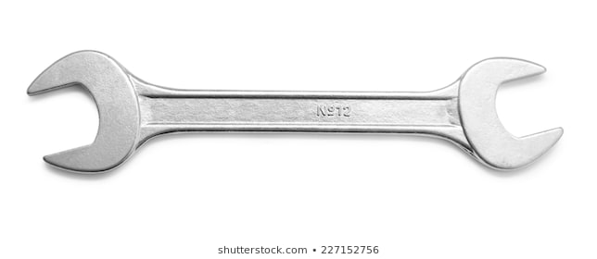Design Brief

Purge points are pipe nipples installed at strategic locations in the piping system to introduce or remove nitrogen and natural gas at various stages of the gas transportation process. Phoenix Gas uses purge valves to let the air out of their gas pipes, these can be strenuous to open and can require multiple tools. Our brief is to design a mechanism which can be used to loosen and release the uppermost nut in a one-inch ball valve which is used as a purge point in the pipe network.  This valve is situated underground in an inspection chamber (20 -30cm below ground) which has a variety of accessibility issues.

Current Solution



We need to create an easy-to-use tool which will replace their current mechanism, and which requires minimal effort to use by the operator. We need to create a mechanism which can be used in reduced access and that will loosen the valve without causing potential damage to the crimped plastic piping.

The problem can be subdivided into two parts – a device to clamp the valve’s body and a part to unscrew the valve’s head.

Two wrenches are currently used to unlock the purge value.

This means that two separate tools are needed. These two tools take up space and require a lot of force and pressure to be successfully used to open the access point. This solution is problematic and could cause potential long-term strenuous injuries. It is also causing potential damage to the plastic piping, and therefore it needs solving.

Trip to Phoenix Gas

At the beginning of the project, we were given the

opportunity to visit the Phoenix Gas headquarters. On the 8th of November, we left school and went to the head office on Airport Road. On arrival, we were given visitors badges and brought to a conference room to work on ideas. We were given a selection of different tools, for example, spanners and sockets of different sizes to test out on valves. There was also a whiteboard where we drew up possible solutions. We think this process was extremely important in the development of our project as we all shared what we would like to see achieved. Through this, we established aims as a team as well as recognised some of the obstacles we would face in the manufacturing process. This experience was very beneficial to the team as we all aspire to be engineers. It gave us an insight into what a career in engineering could involve. As well as this, it also showed us how everyone’s role in the team can be very different, but each as valuable as the others.

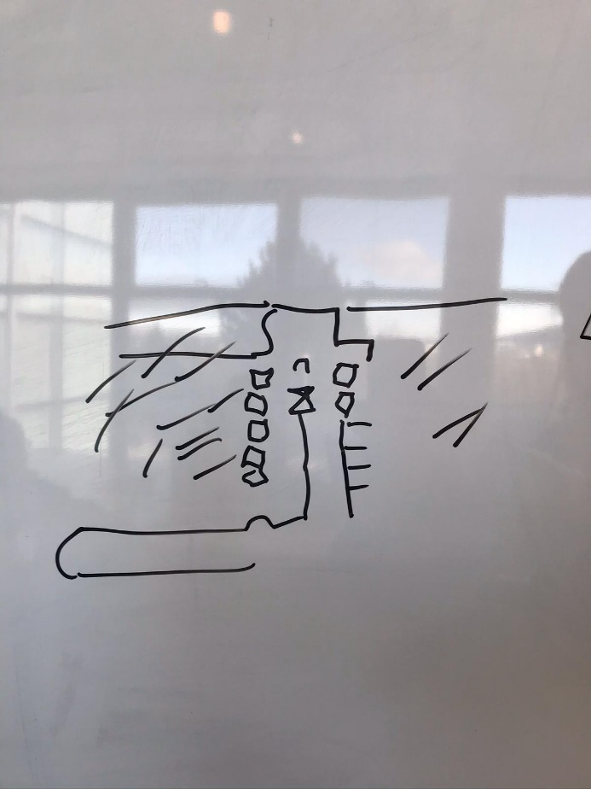

After a while of coming up with our initial ideas, Neil Preshaw, our link engineer, gave us a presentation about Phoenix Gas and what they do. This gave us an insight into how the ball valves are used and why the engineers need to be able to open them quickly in the case of a gas leak. We were also shown the control room which monitors the gas network across Northern Ireland.

After leaving Phoenix Gas we went on a site visit to see work being done near Ormeau Park. As this was a much bigger chamber it showed us that the purge

valves are used in places other than in the standard inspection chamber. This working site provided us with an insight into the problem we are trying to solve. It also helped the team envision as well as build on our possible solutions more clearly as we could see the reality of the accessibility issues.

Initial Idea One

*Problem - Design a mechanism which can be used to loosen and release the uppermost nut in a one-inch ball valve which is used as a purge point in the pipe network. This valve is situated underground in an inspection chamber [20 -30cm below ground] which has a variety of accessibility issues. The valve releases air from pipes.*

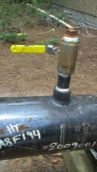

**Solution -** This solution involves two separate parts. The first part involves a long metal pipe (at least 20-30cm long), with an adjustable wrench at the bottom. The wrench can be adjusted to suit the different sizes of purge point used. Ideally, the wrench could be tightened to provide a strong grip to prevent the purge point from possibly moving during usage.

Possible problems that would have to be solved are:

1. How the two mechanisms could be attached together and,
2. How a strong grip and adjustable wrench could be achieved without causing strain or injury to the user

The second part would be used to loosen the uppermost nut from the purge point. Like the first part, there would be an adjustable wrench to suit different dimensions of nuts used in the system. The system would then be turned to allow the nut to be loosened and released. To achieve a strong grip on the uppermost nut, a plastic grip or a rough metal ending could be used to prevent the nut from slipping out of the mechanism during operation.

If possible, the two mechanisms would be attached together to allow the nut to be released by a single person, which would save time and resources. This part proves to be the most challenging as we would need to design a mechanism which could attach the two parts together without affecting the turning mechanism on the uppermost nut.

[](http://www.google.co.uk/url?sa=i&rct=j&q=&esrc=s&source=images&cd=&cad=rja&uact=8&ved=&url=/url?sa%3Di%26rct%3Dj%26q%3D%26esrc%3Ds%26source%3Dimages%26cd%3D%26ved%3D%26url%3Dhttps://www.amazon.co.uk/Olympia-01-015-15-Inch-Adjustable-Wrench/dp/B000VJNONU%26psig%3DAOvVaw2QsWTf0naBYotrVa88nyFa%26ust%3D1574264356700524&psig=AOvVaw2QsWTf0naBYotrVa88nyFa&ust=1574264356700524)Initial Idea Two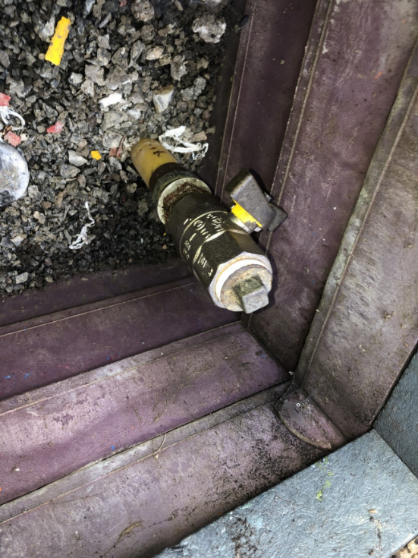

This solution focuses on the attachment to secure the bottom part of the mechanism to the valve.

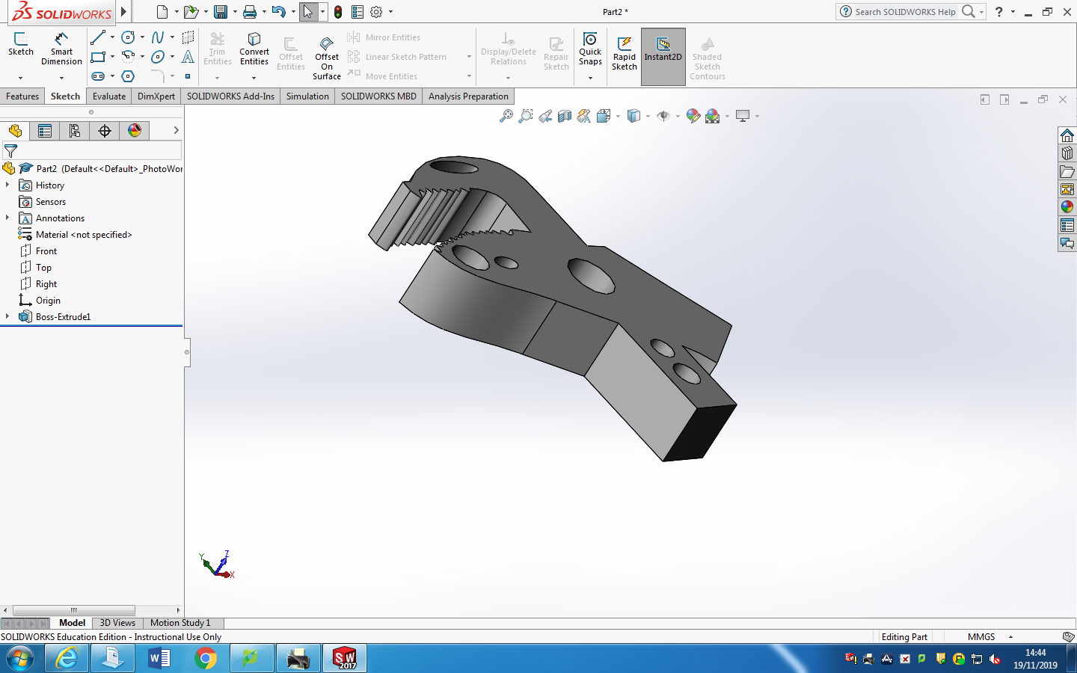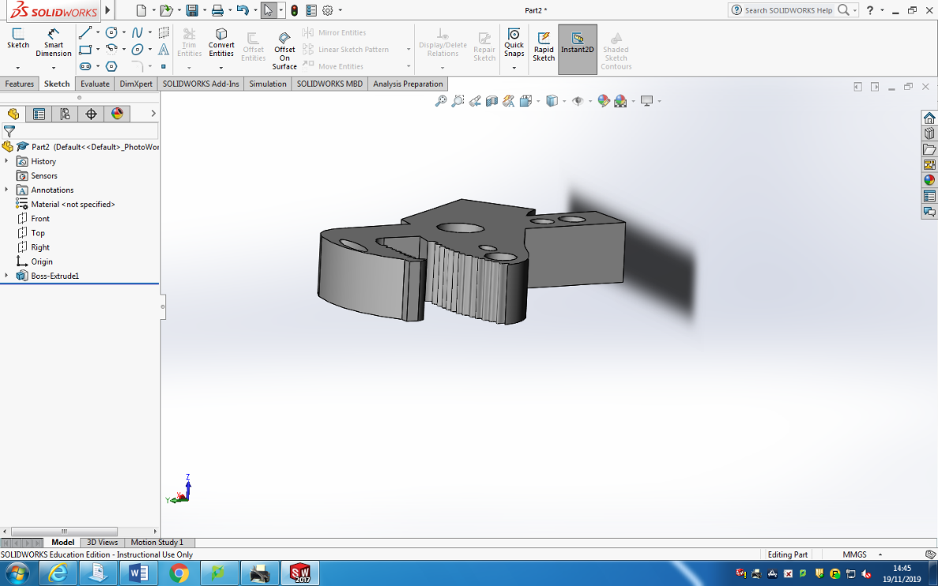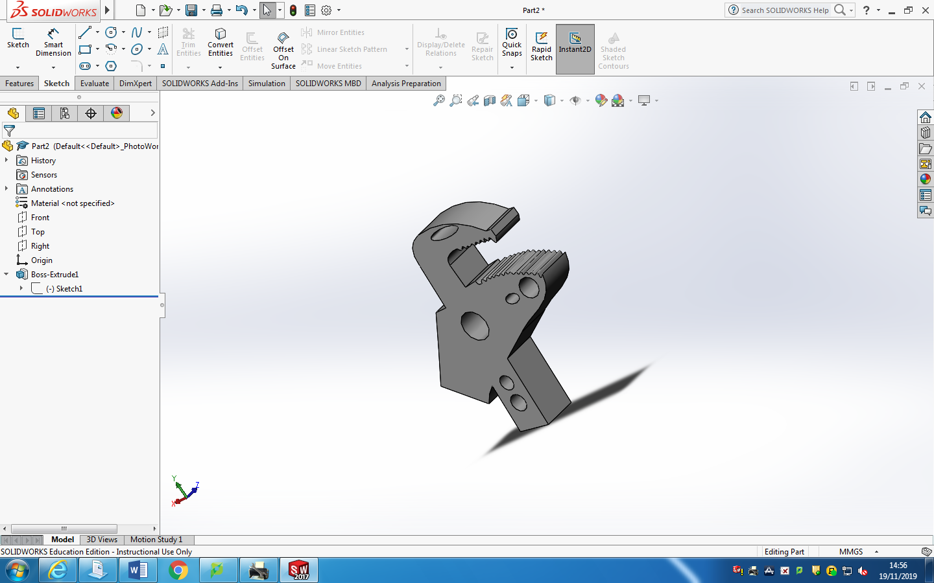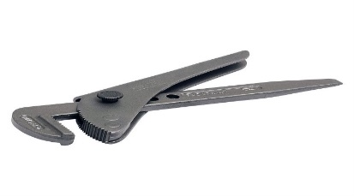

The inspiration for the adjustable clamping mechanism comes from adjustable footprint tools, such as the one shown below. With the adjustments of a handle or bar at a vertical 90-degree angle to the head of the tool, we believe that this mechanism will be improved further.

**Solution -** The parts shown will be used to secure the bottom part of the valve whilst the top is being removed. This is very important as if it is not held in place, it can be a risk to the engineer and cause potential injury. The arm will be connected to this part at a perpendicular angle to provide strength and support. The head of the part, which will be used to secure the mechanism to the valve, should be adjustable as the valve comes in different shapes and sizes. However, this could cause issues as the parts of this will need to be fully encased and waterproofed to prevent the rusting and seizing up of metal parts.

**Solidworks designs:**

Initial Idea Three

**Solution –** The drawings show a possible solution to this problem. As the hexagonal valve needs to be clamped in place while the ball valve is removed, this solution consists of two key features.

1. Feature 1 is the part which will remove the uppermost nut. The cubic socket will surround the valve and then the handle will be spun in order to turn the socket which will remove the valve.
2. Feature 2 is the part which will hold the hexagonal valve in place to prevent gas leaks. The square head will surround the hexagonal valve in a fixed position so that it cannot move. Part of the problem with this valve is that there are some variations in sizes. To overcome this problem, the tool head is interchangeable in feature 2, meaning a different-sized head could be used instead. The heads will be secured to the rest of the toll using a nut and bolt.

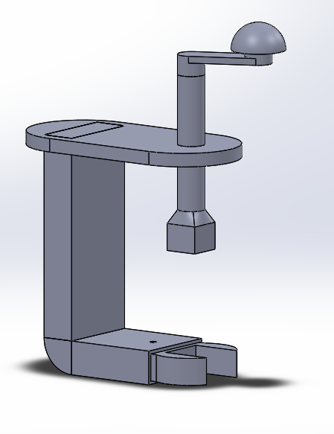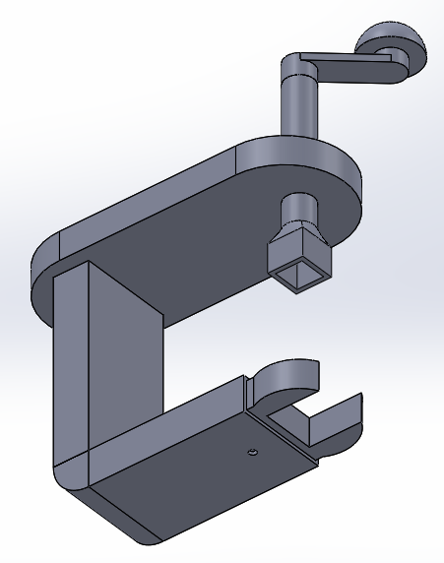

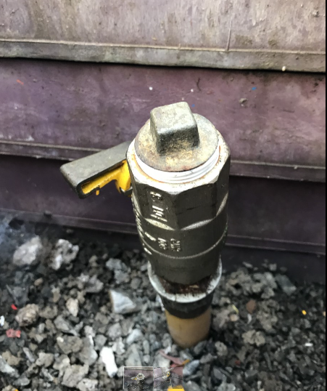

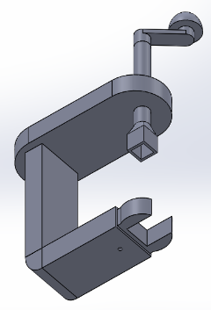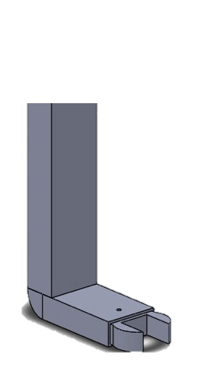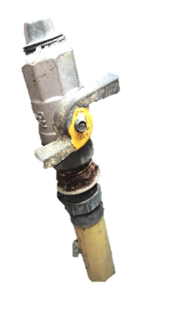

**Feature 1.**

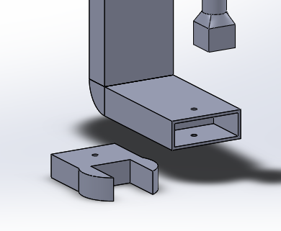

**Feature 2.**

Agreed Solution

The Design

We agreed to develop idea three further in order to create a solution for the problem. This design was chosen as it acts as a simple solution that would accomplish the goal of removing the uppermost nut from the purge valve while still holding the hexagonal valve in place. The design is quite compact which will allow for it to be easily used by one person instead of being a two-person job which is sometimes the case. The design incorporates the two main problems of removing the nut and holding the valve in place all in one tool which improves the ease of access to the small chambers surrounding the purge valve.

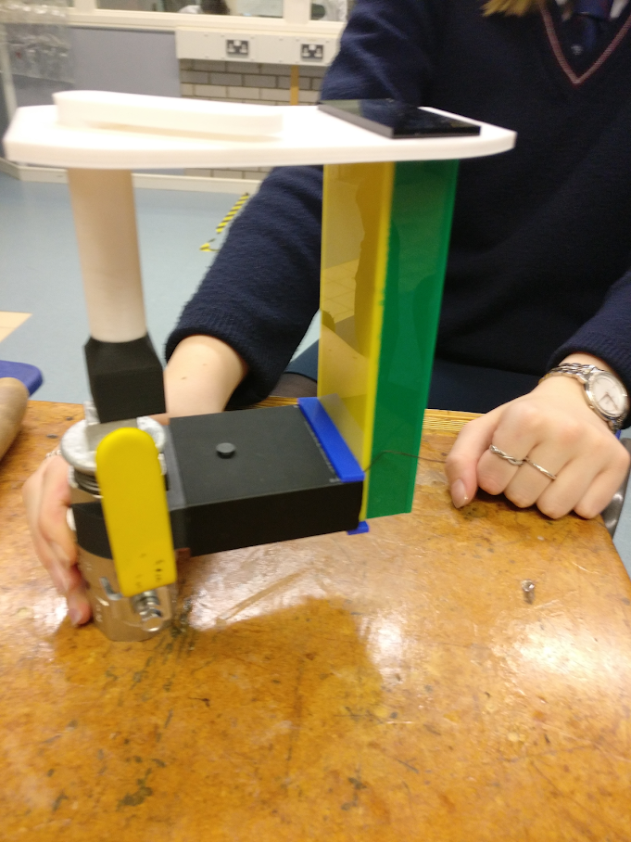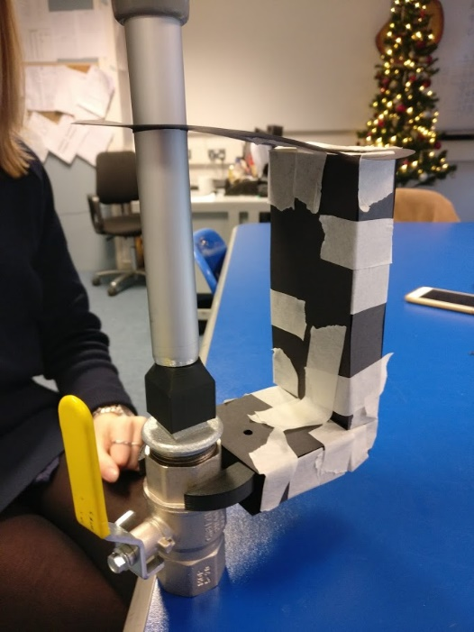

A plastic prototype of this design was also created using both 3D printing and laser cutting.

From this model we discovered that a minor alteration was needed, in that the crank arm needed to be moved 5mm closer to the edge of the part to line up better with the purge valve in the plastic model and eventually metal. Plastic is not as flexible as the card and so no longer fitted.

Shown to the left is a card model of the simple design. From this, we determined that the model worked and that it could unscrew the purge valve head successfully.

The card model was produced in 2D using a laser cutter and the individual parts were stuck together using masking tape. Our Solidworks designs were converted into 2D DXF drawings and imported into Laser Cam for printing.

**Prototypes:**

Testing and Modelling

In order to test our solution fully we had three purge point valves made up for us:  
- The first valve was used to test the basic functionality,  
- The second valve, which was crimped onto the plastic piping, was used to ensure that removing the cap did not damage the connection and,   
- The third valve, which comprised of two purge valves connected to a pipe, was used to test a range of functions.  
  
We also had access to two live purge valves outside our school gates. We decided to make two initial models; one made from metal and a second wooden one. After we had made the required refinements to these two models, we then made a third plastic model.

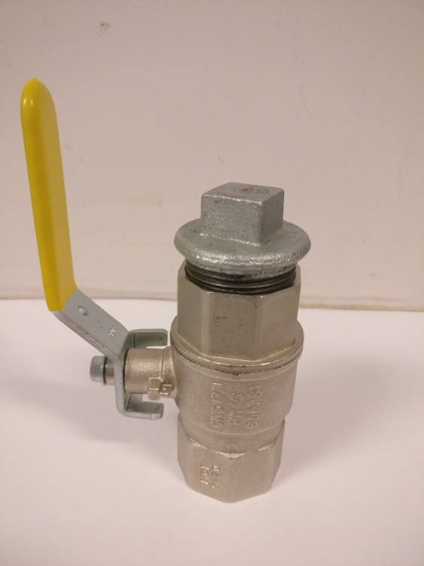

The valves used by Phoenix Gas differed in size due to the fact that they have been supplied by different suppliers over the last twenty years. As a result of this, we would need a model that was able to open a range of different sizes and so it needed to be tested on the older models. The valves outside the school gates were the older type, so if it worked on them and the new ones, we could conclude that the tool was successful and that it could open all the different types of valves.

Fabrication Process

We decided to develop our first model for real-world application, and to do so we would need to fabricate the product.

We explored several possible routes to carry out the fabrication process, such as building it in school (if we had the resources), collaborating with Queens University and making it using their facilities, or going to an independent fabricator to bring our idea to life.

We thought about a variety of methods to fuse the pieces of our project, such as glue, soldering, welding and brazing. This model is fused using welding. This process is more effective as it is stronger, more efficient and more aesthetically pleasing compared to rivets or soldering. This is vital as our product has to withhold a substantial amount of pressure. For example, a standard ball valve takes 30 Newtons to turn, and so the metal joins in our product will have to withstand a force of 30 Newtons. Welding our product not only allows it to be durable but also gives us the ability to join curved pieces, corners and to attach outside pieces, such as a hinge (as seen in the model.)

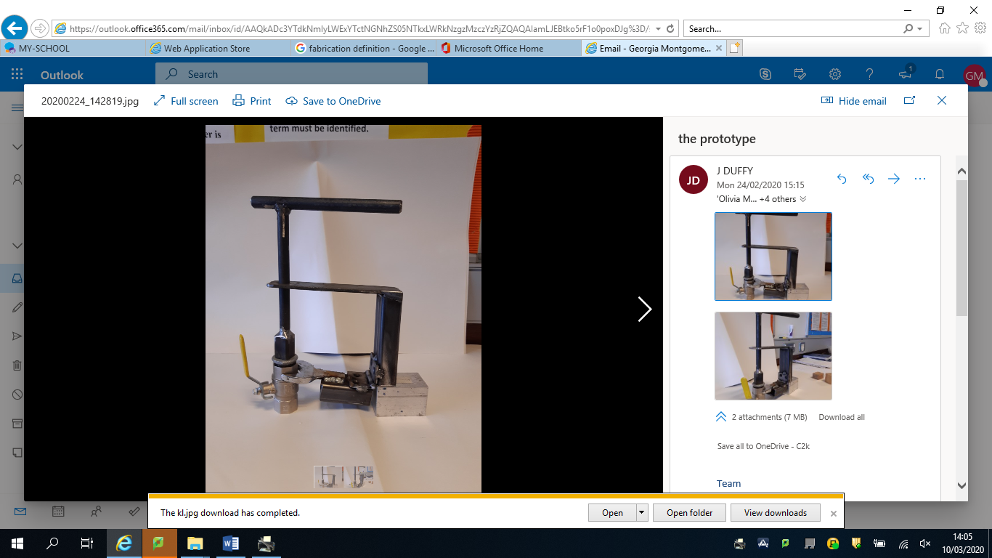

**Advantages**

* The design of our product can easily produce the turning force of 0.63 Newton metres required to loosen the ball valve.
* All the measurements shown in the product and the working drawings are all accurate for real-life application.
* The product is one singular form and is compact, therefore it can be transported easily.

**Disadvantages**

* The hinge could make it difficult to attach to the ball valve, especially when in the ground.
* It is heavy which could increase the labour needed for the job.

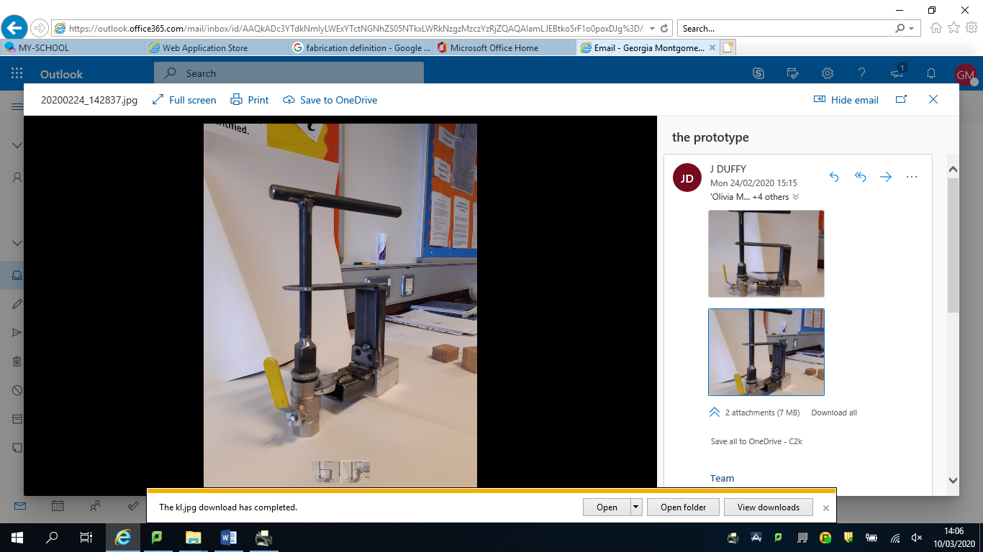

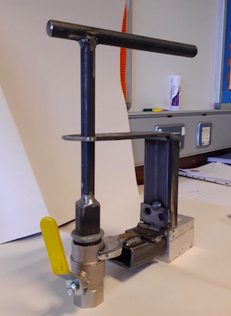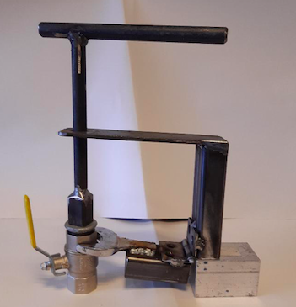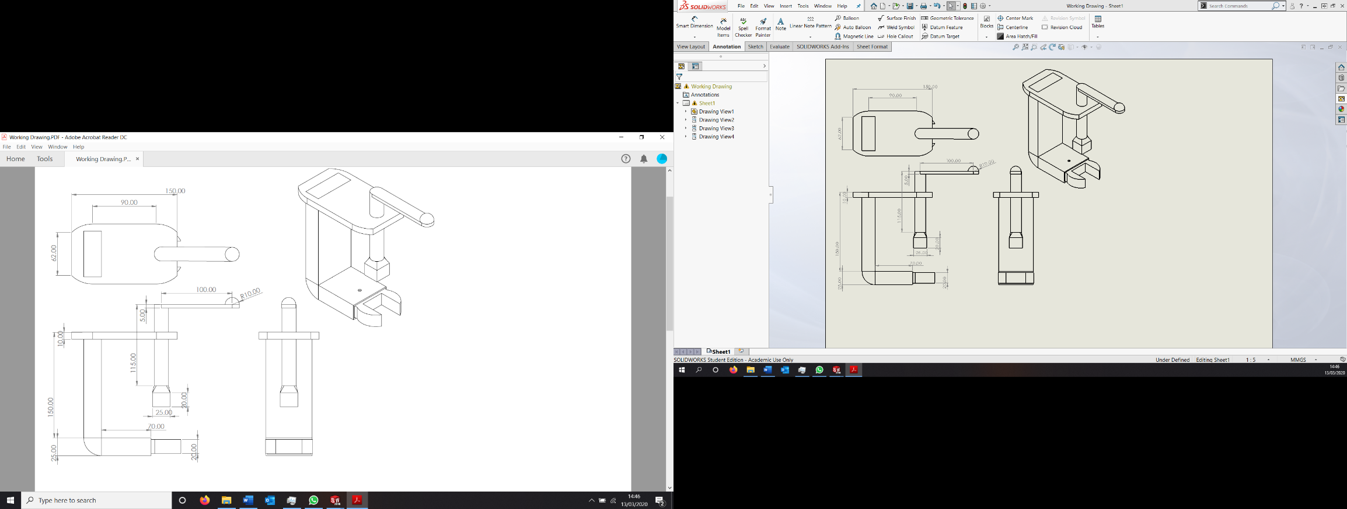

The prototype we received differs from the original design as it featured a hinge which enabled the spanner end to fold completely flat. The fabricator added the hinge to the design as he believed it would improve the transportability of the product. For the purposes of the photograph the part was supported by a small box. When testing this product, it was quite difficult to secure the spanner end to the hexagonal section due to the loose motion from the hinge. The tool had to be held at a specific angle otherwise the weight of the product was not supported, and the spanner wouldn’t fit securely onto the valve. We decided that the product would function better if the main body of the tool was kept as one solid part, as detailed in the original designs.

After making the adjustments to the solid works designs, we converted the files to working drawings which detailed necessary dimensions of the product. The images to the right show drawings of the design at this stage in the process.

These files were then printed using a combination of an FDM printer and a laser cutter. After this we brought the model to a metal fabricator for a prototype to be manufactured. The prototype shown to the left and below was manufactured using a variety of steel box sections and rods which were welded together. The parts used were standard sizes in order to reduce the manufacturing cost.

Metal Prototype

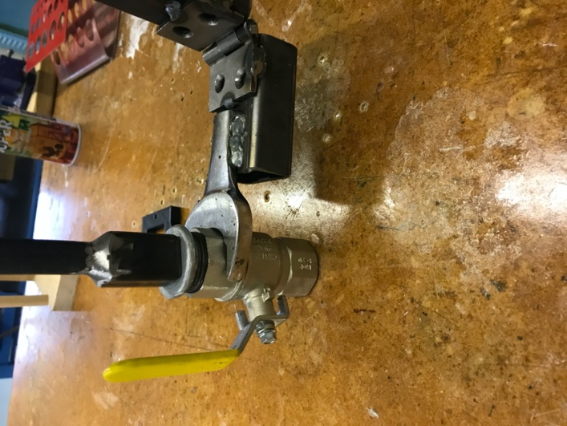

As shown in the image below, the tool successfully removed the socket from the valve while the spanner was able to keep the valve in place preventing any potential leaks.

We tested the prototype in an indoor environment to check that the tool was able to provide the correct turning force to remove the socket from the valve. The images to the left show testing which took place in the workshop on a separate purge valve.

Testing Metal Prototype

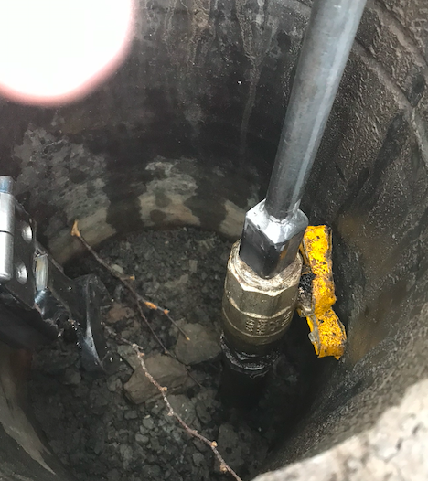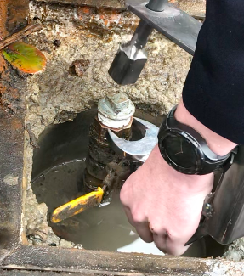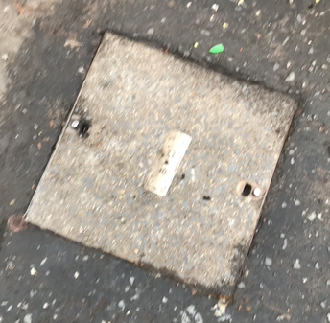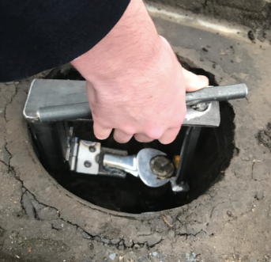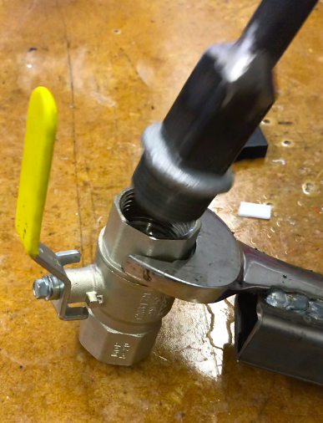

As the valve could not be tightly secured, we were unable to remove the socket from the valve in order to prevent potential gas leaks.

After successful testing on a modelled part, we completed testing on a real-life purge valve system. We tested the prototype on a purge valve system located behind our school. During the testing we found that the prototype could successfully fit into the small chamber and still have adequate room to function. We also found that the square head of the socket fitted easily into the tool head. While the majority of the prototype functioned well, the spanner end did not fit onto the hexagonal valve as it was simply too small. As this was an older valve, the dimensions were slightly different to the one we had been using for calculations and previous testing. This fault was expected.



The main problem that arose from testing the prototype was that the spanner would not fit onto the second purge valve. As Phoenix Gas have been distributing natural gas for over 20 years, there are many variants in dimensions of valves due to manufacturer changes. In order to fix this problem, we decided to amend the design of the first prototype. By changing the spanner from being fixed to adjustable, the tool will be able to be used on a variety of purge valves.

Problems from Testing

Another problem that arose was that the tool head, which removes the socket from the valve, did not completely secure the socket. When testing the prototype indoors it was found that the socket could fall out of the tool as there was no method of securing the socket in place. This would be a big problem as many of the valves are located in deep chambers and if the socket was to fall from the product, it would be quite difficult to retrieve.

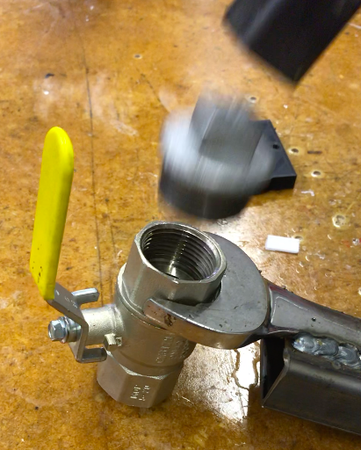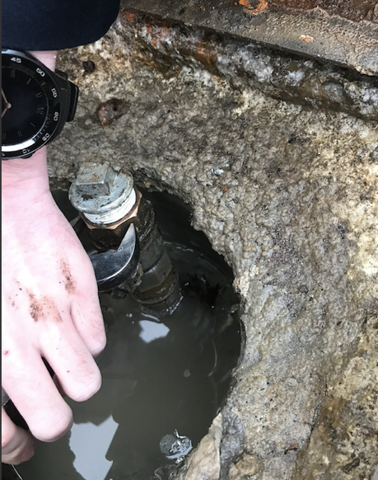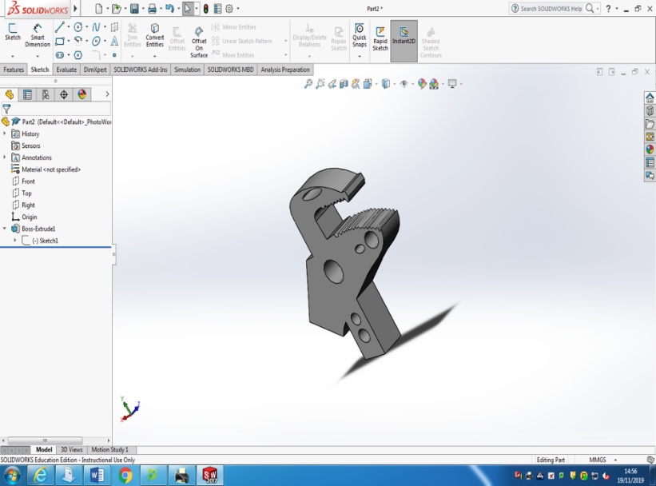

In order to improve the design, we decided it may be possible to incorporate some of the features from idea 2 to the prototype.

When the arm to the right is rotated, the crank arm moves shifting one half of the clamp either closer or further away from the other side to allow different sizes of caps to fit.

Once this is done, the entire part can be rotated to allow the cap to be taken off through the use of the larger handle.

The drawback to this method is that a large moment will be created on each handle (in the up/down direction) and that could be enough to snap it off. A motor system or gear box could be designed which would allow the operation of this mechanism without the use of a long and potentially fragile handle.

The gearbox system would be harder to design and would be likely to seize up over time however it would not require power like a motor system would and a similar system could be used as in wind turbines but in reverse – high speed to high torque.

Further problems to be solved:

* A mechanism to clamp the body of the valve.
* A method of avoiding a large handle to open the valve.

**Solution -** The part would be used to secure the cap of the purge valve and adjust the size of the grip so that it could be used on different sizes of caps, the design was created through the use of the CAD package Solidworks. The introduction of an adjustable size grip would be beneficial as it would allow our mechanism to be used on a range of purge points, adding to our products usefulness.

The diagram to the left shows a mechanism on how to convert rotational motion to linear motion and this design will be the basis of this potential design.

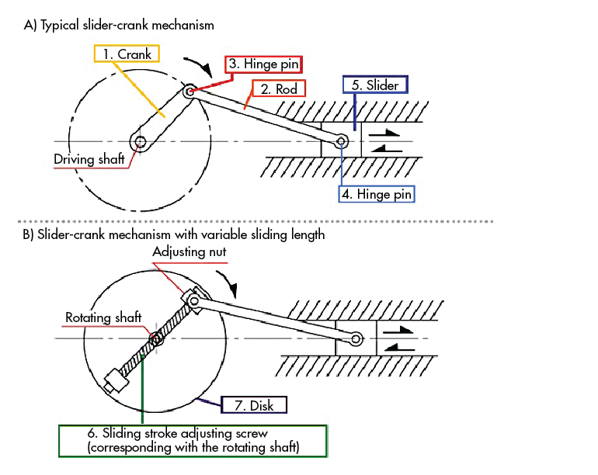

Image Source (Layosa, 2018)

The first feature we decided to improve was the tool head clamp.

Improvement Solution

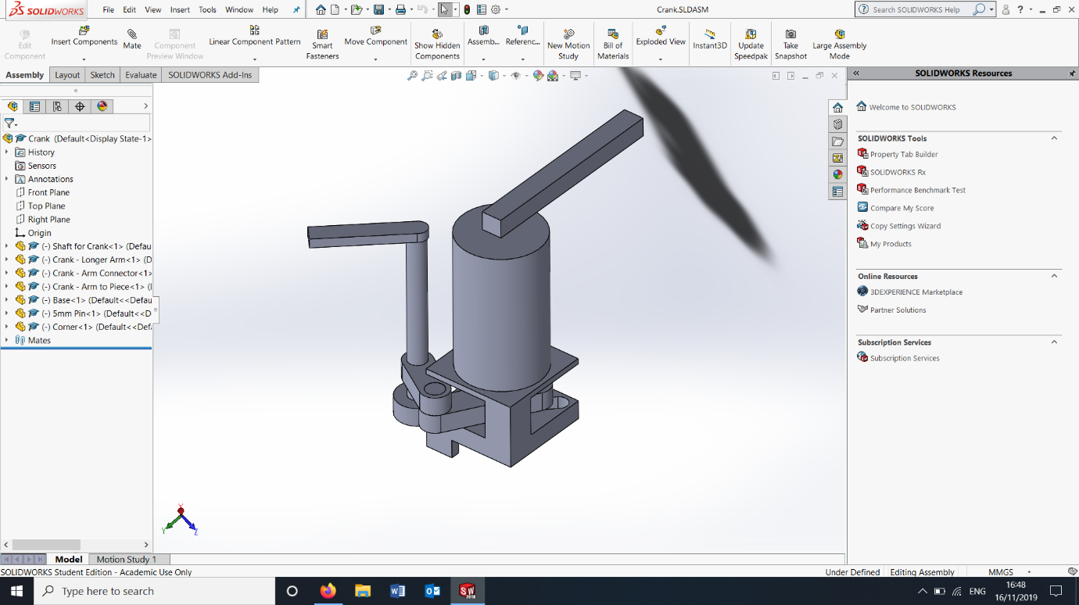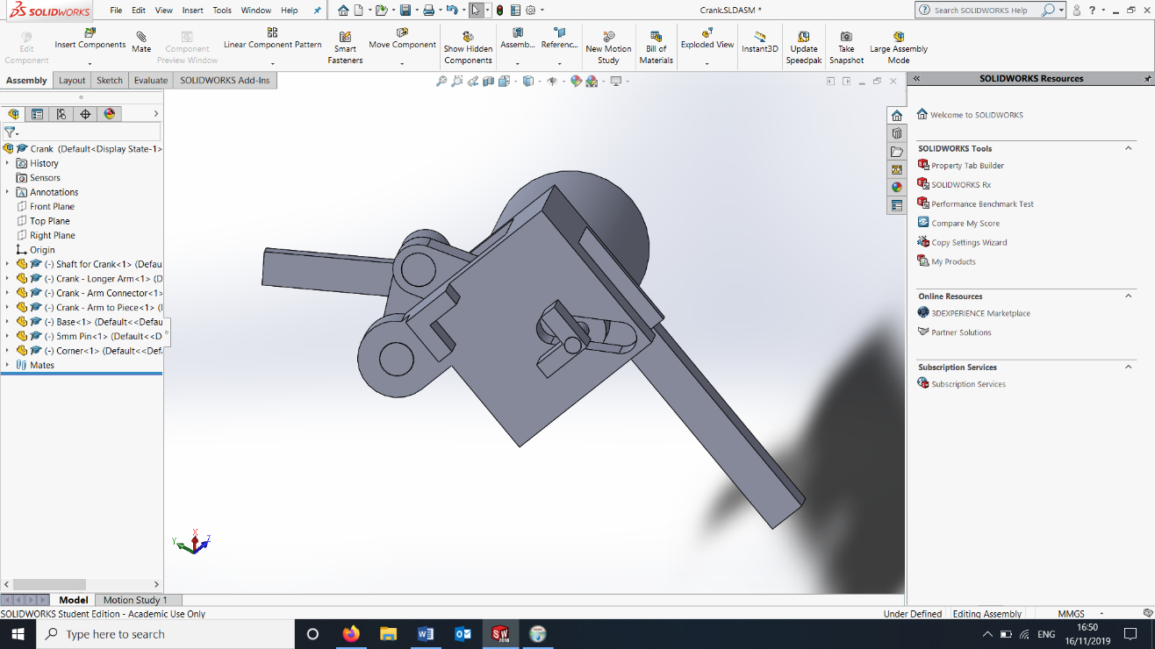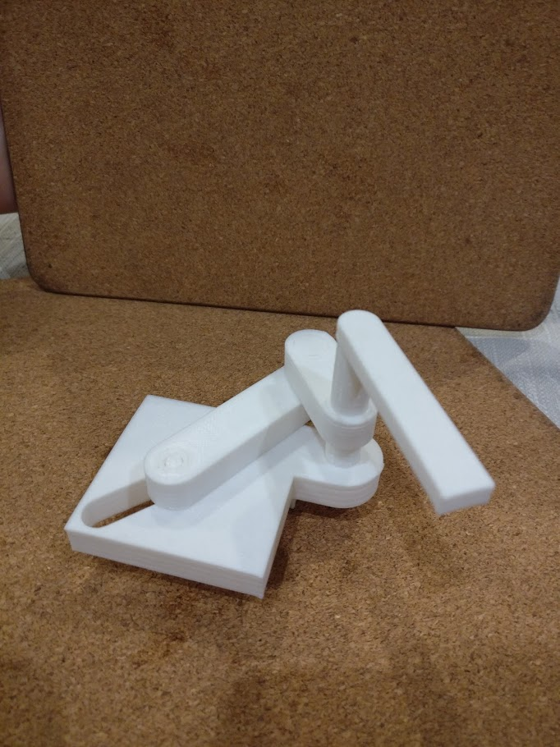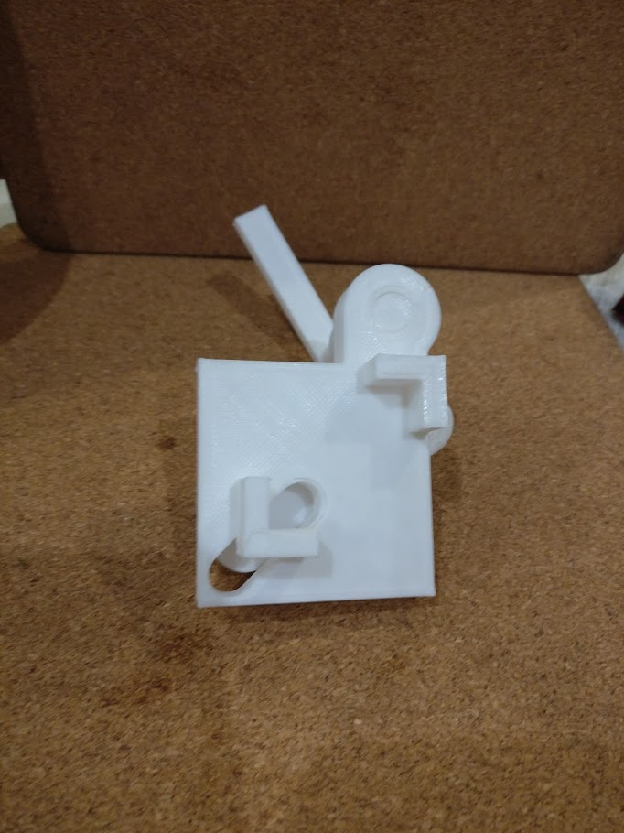

The two pictures to the right and below shows a 3D printed prototype of the adjustable cap mechanism, this proves that the mechanism works and is a feasible design. The material PLA was used as it is biodegradable and therefore not as harmful to the environement.

**Solidworks designs:**

This solution focuses on the attachment to secure the cap of the purge valve.

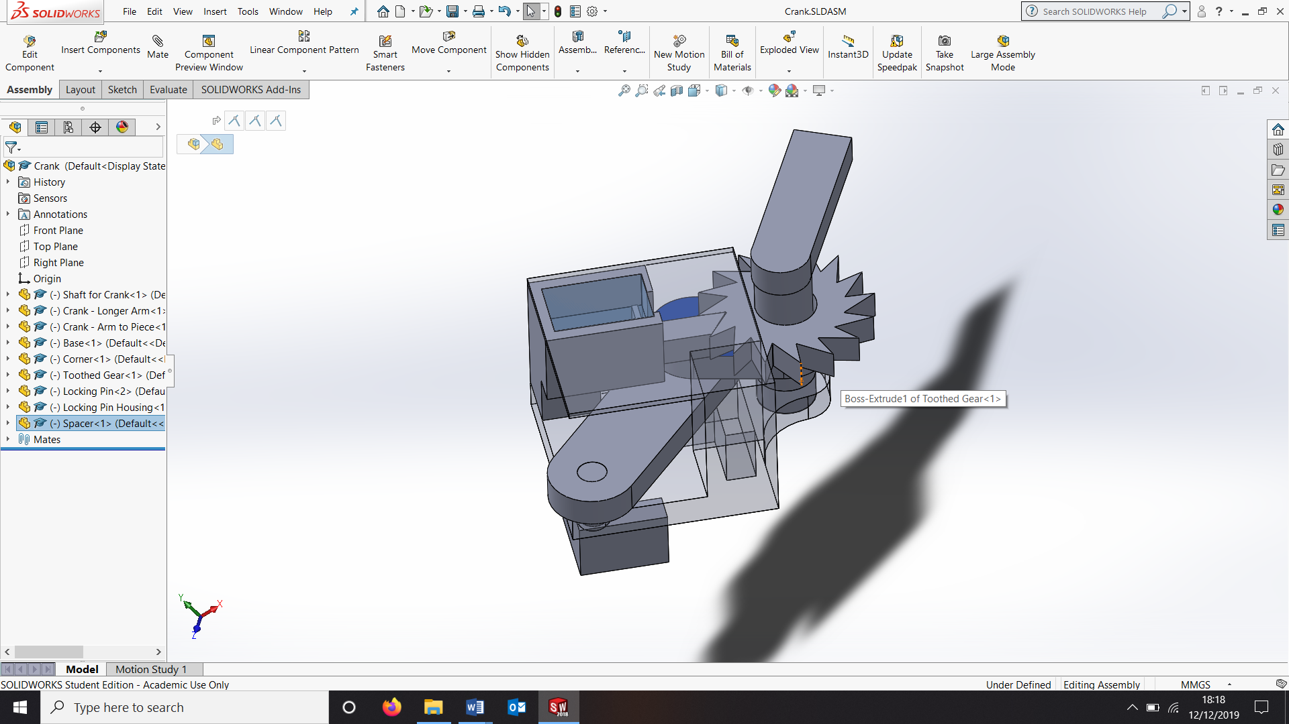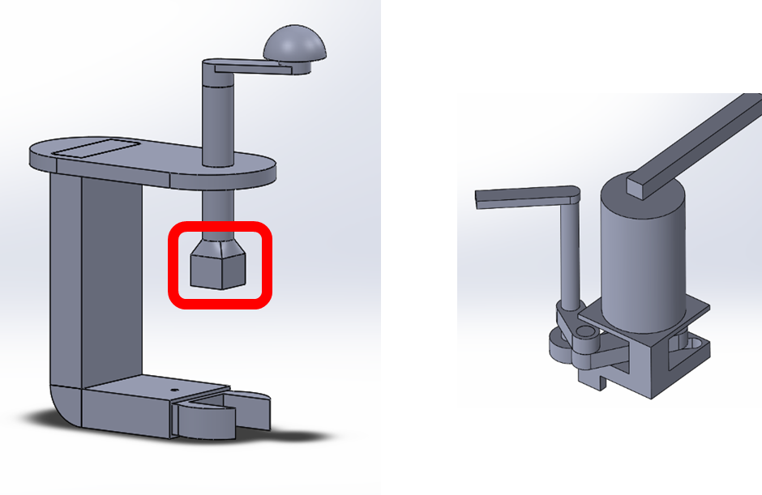

This was the first revision of the design. The adjustable part of the clamping mechanism can now be locked so that it does not move during rotation.

It is also significantly smaller than the original design. A pin is forced into a one-way gear so that it can only rotate in one direction. A spring holds it in place. The gear can be slid up about its axel so that it can be rotated in the other direction before being slid back down.

The required spring could be calculated using Hooke’s Law

$$T=\frac{λx}{L}$$

The locking mechanism would be substituted for the part circled in red after further development.

Adjustable Valve Head Clamp

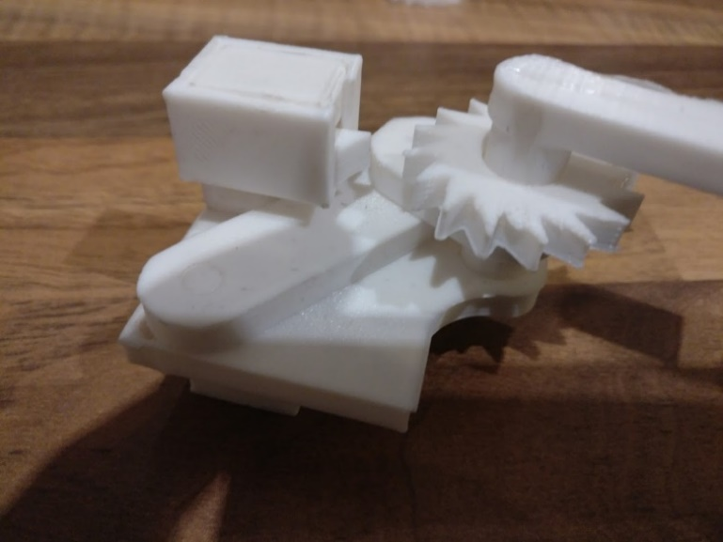

A CAD Drawing for the design is shown to the left. This was then 3D printed.

The first model to the left shows a proof of concept that this design can in theory work.

The second model shows the entire part together. The locking pin design is flawed as it is not constrained enough and can rotate and these needs fixed in a future revision.

The third picture directly below shows the size comparison between the first and second prototypes.

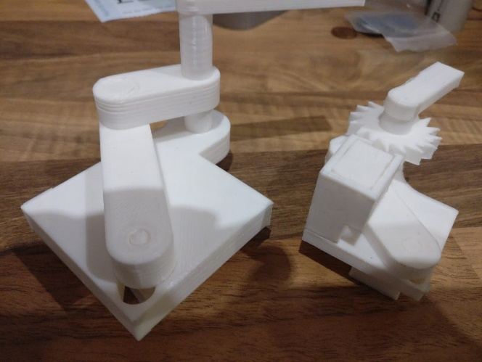

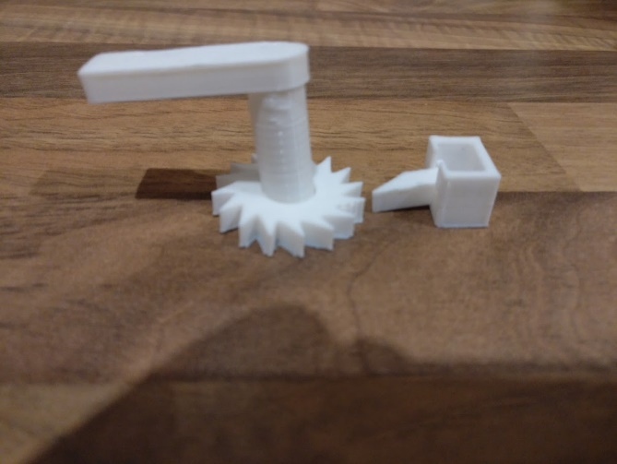

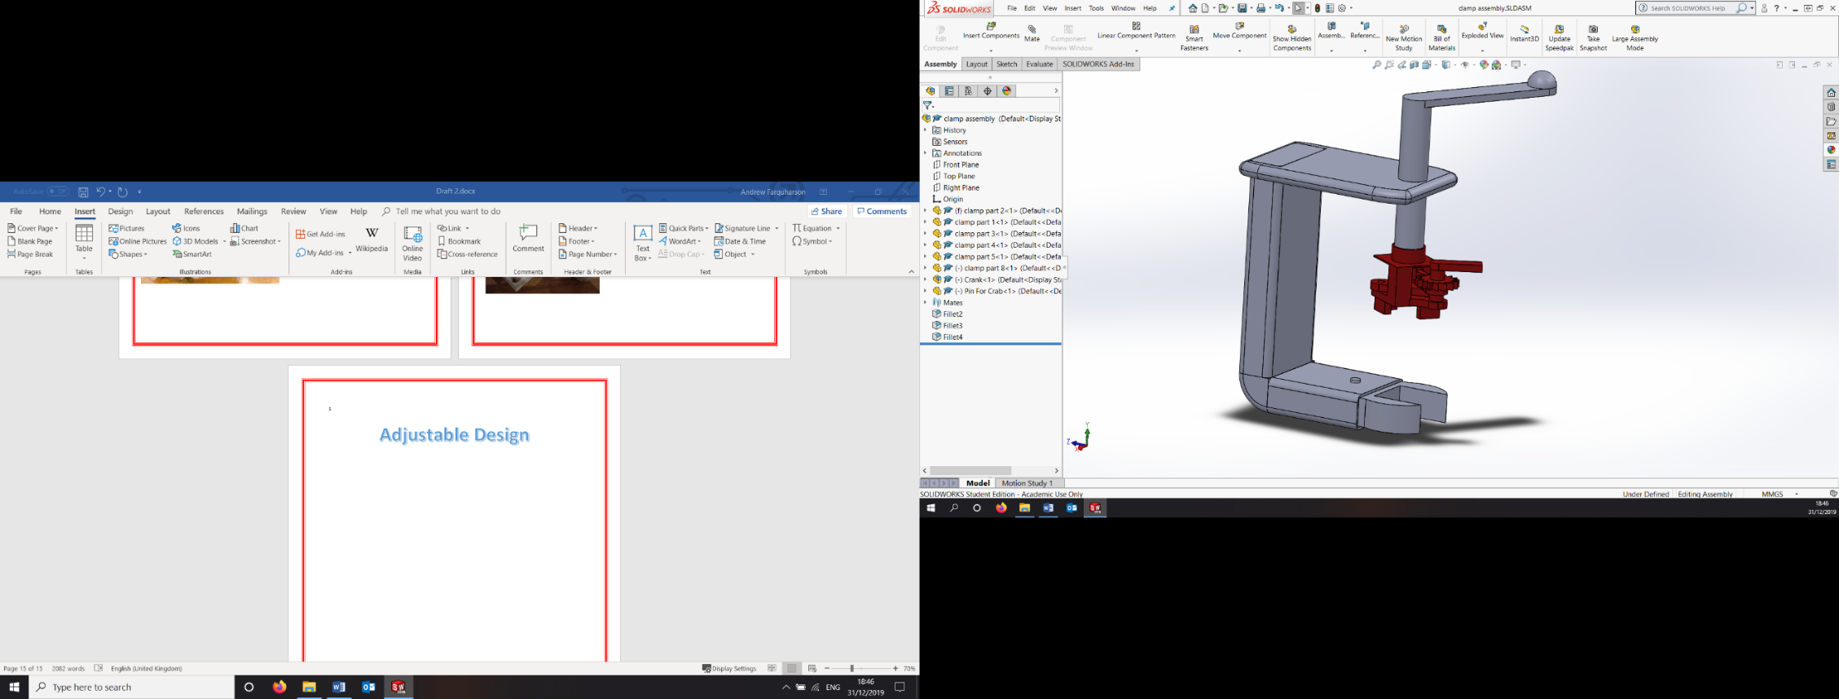

The Solidworks model shown to the left is that of our simple solution integrated with our adjustable locking mechanism. Part of the lid of the clamp has been extruded outwards to provide a good surface for the handle to mount to. Some of the edges of the design have also been filleted to improve the aesthetic quality of the product, and to avoid the user hurting themselves on overly sharp edges.

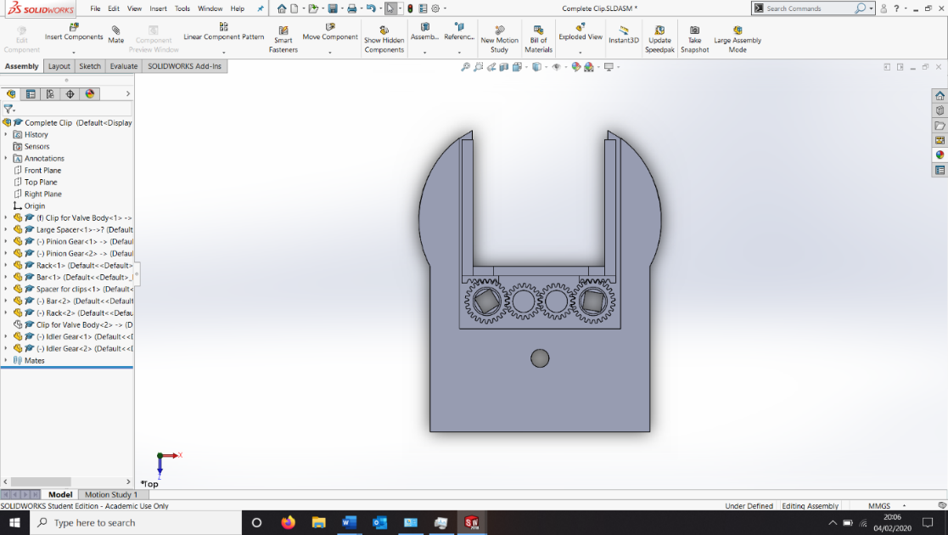

We designed a method of actuation that involved a gear train so that the movement of one side would be linked with the movement of the other, keeping the valve centred and the cap opening mechanism above the clamp. It uses a two rack and pinion setup to allow the rotation motion from an input wrench to be translated to reciprocating motion on the rack.

The body of the valve comes in different sizes as well, so we have opted to redesign the clamp that holds the body of the valve to make it adjustable. We wanted to allow the side parts to move inwards and outwards to adjust the size of the clamping cavity.

Adjustable Body Clamp

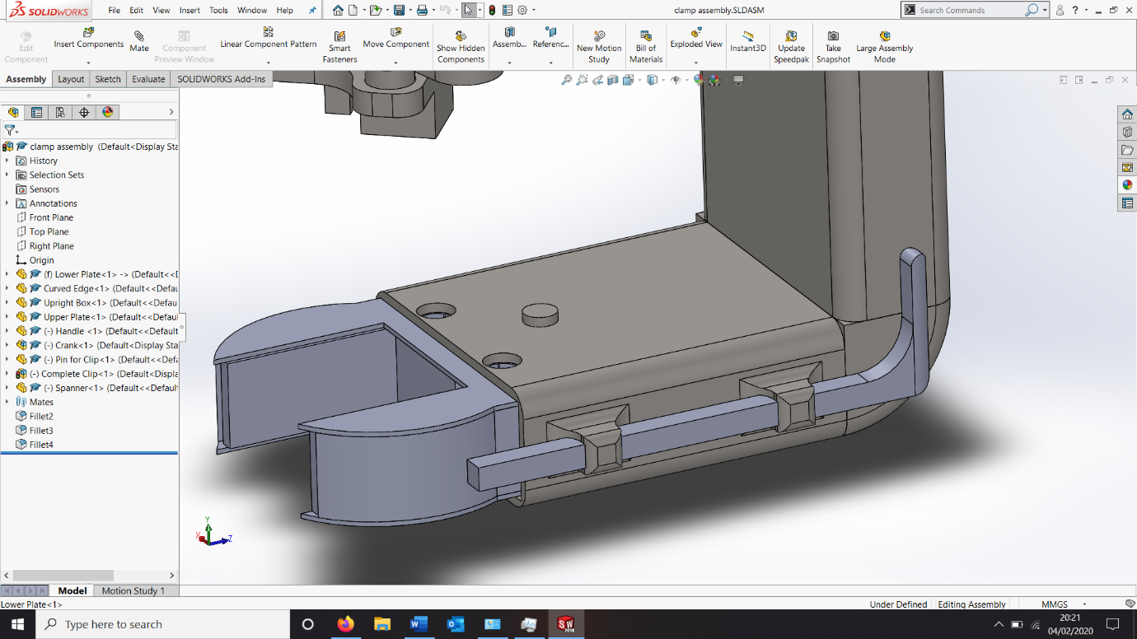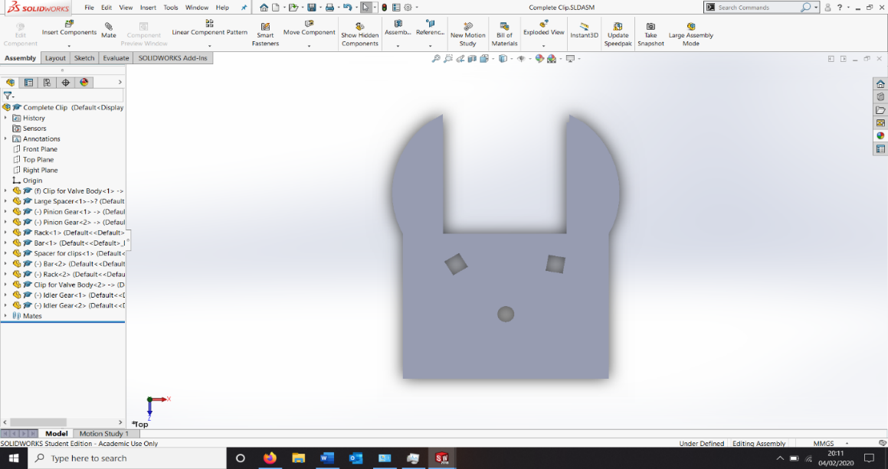

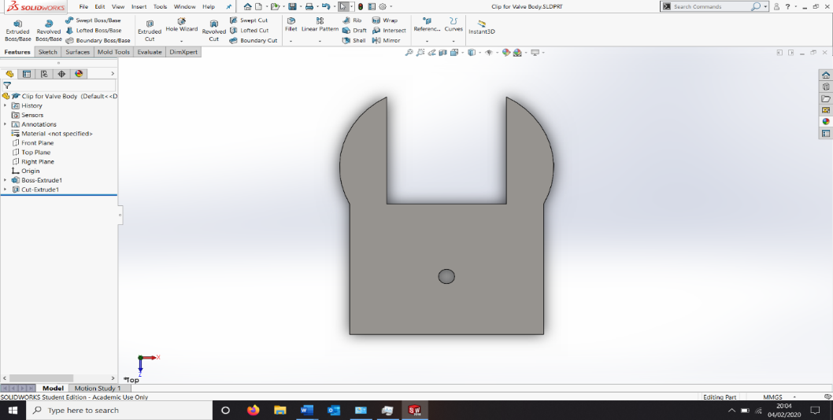

The picture to the left shows the wrench that we designed which allowed the gears to be moved. This has a long handle which allows the creation of a larger moment. It is 0.1m long which means the moment is given by $Moment = 0.1 ∙F$. When testing our parts, a torque meter could be used to measure the force necessary to operate the gear train.

The downside of the wrench is that it is a detachable part and so could become detached and lost so we decided to develop a mount for this part.

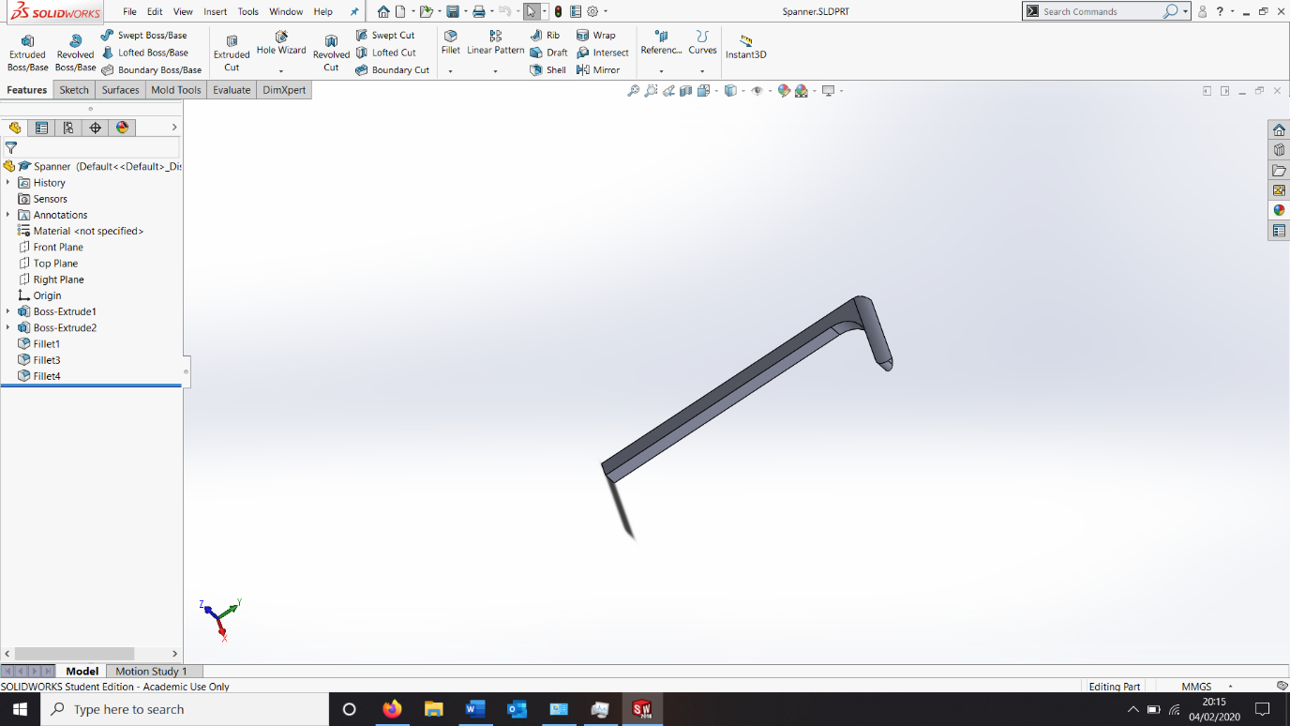



Shown to the right is the completed clip with the cover on it which only exposes the square cut-outs to move the gear train. It only needs one however two allows the product to be used by both left and right handers as easily as each other making our product ambidextrous.

We then opted for a simple gear train with no compound gears but with two idler gears to ensure that the rack and pinions move in opposite directions as we want them both to move inwards or outwards in sync. We know that the gears will move in sync because of the formula $Gear Ratio = \frac{diameter of driven gear}{diamter of driver gear}$ as both pinions gears are identical the gear ratio is 1:1 meaning that the gears will move in sync. We then decided to create a 3D printed model of the gear train that allowed this mechanism to function.

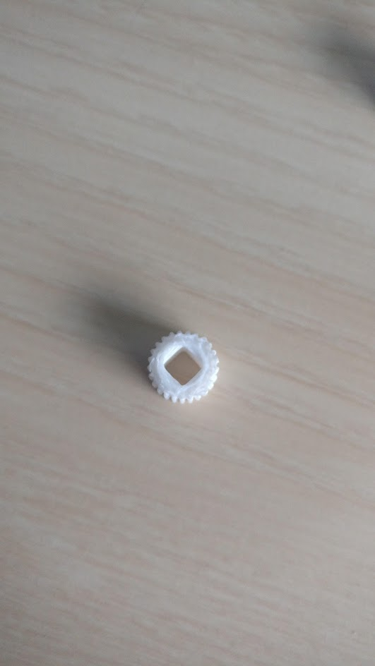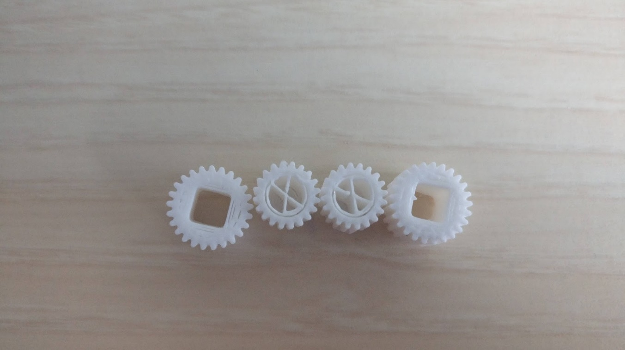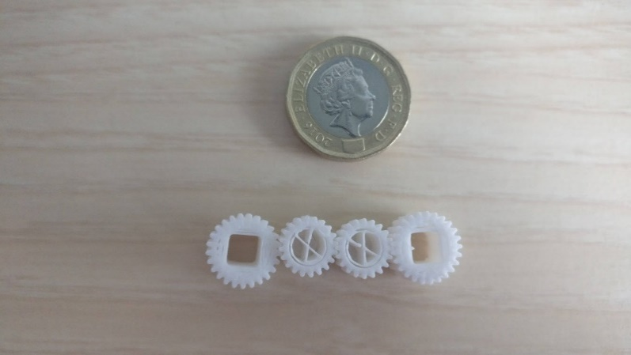

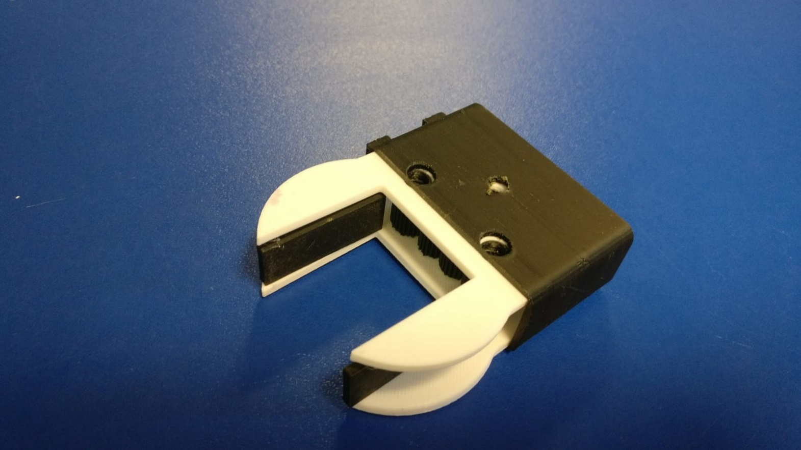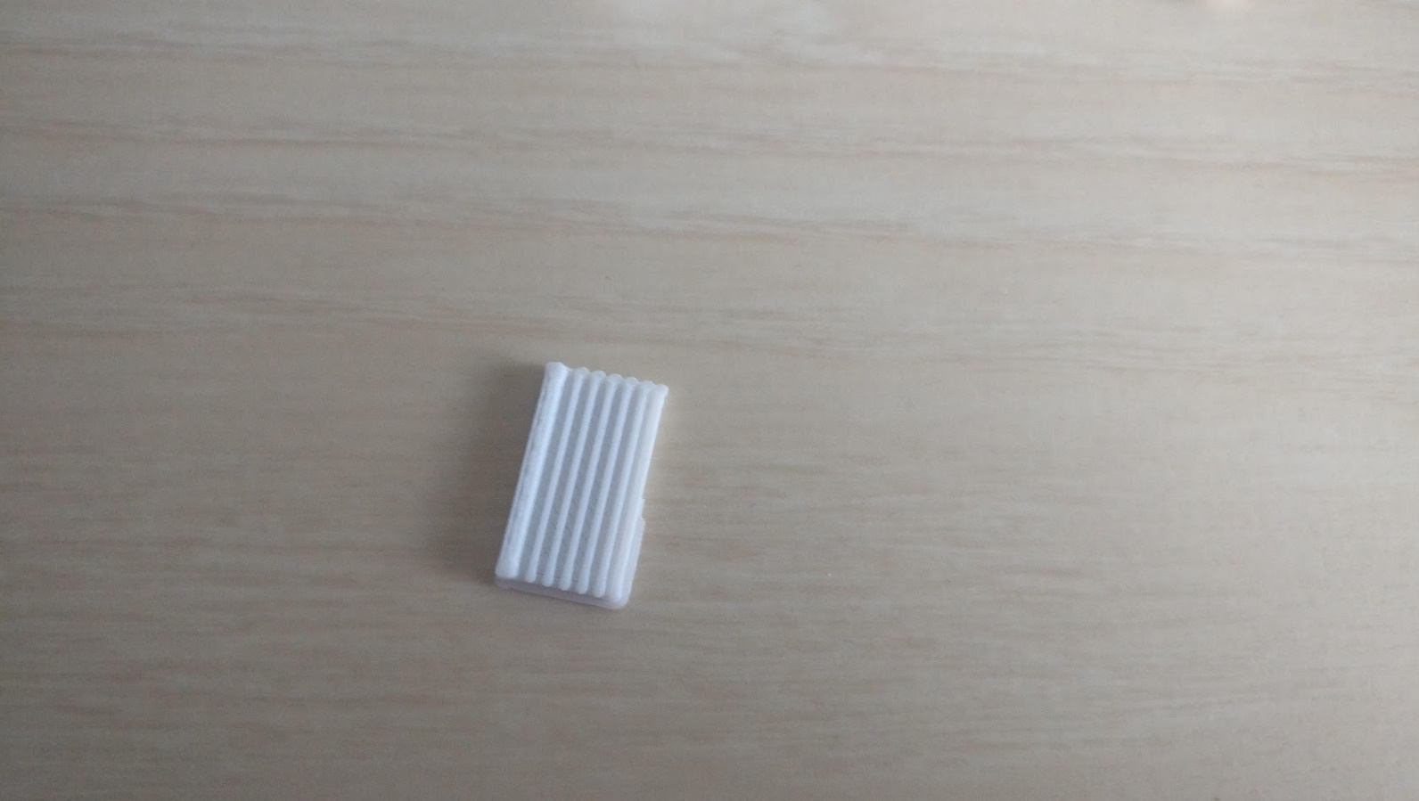

However the part which allows the gear to be seated inside the clamp is only 1mm thick and it did not print as expected; to fix this we will increase the thickness of this part from 1mm to 3mm to ensure that the gears stay in place. The gear train is pictured beside a pound coin below for a sense of scale. The rack part of the rack and pinion printed well however is it slightly thin and thus on the flimsly side of its thickness will be increased from 1mm to 2mm as well.

After the initial testing of the feasibility of the gear train mechanism we decided to 3D print a model of the complete bottom clamp to ensure that it works as a whole and not just in theory.

One of the problems that we encountered was to do with tolerances in that 3D printers produce parts that can differ from intended by as such as 0.5mm and while this does not sound like much it ment that the gear cover needed to be manufactured three times luckly as 3D printing is very quick this process was completed within a day.

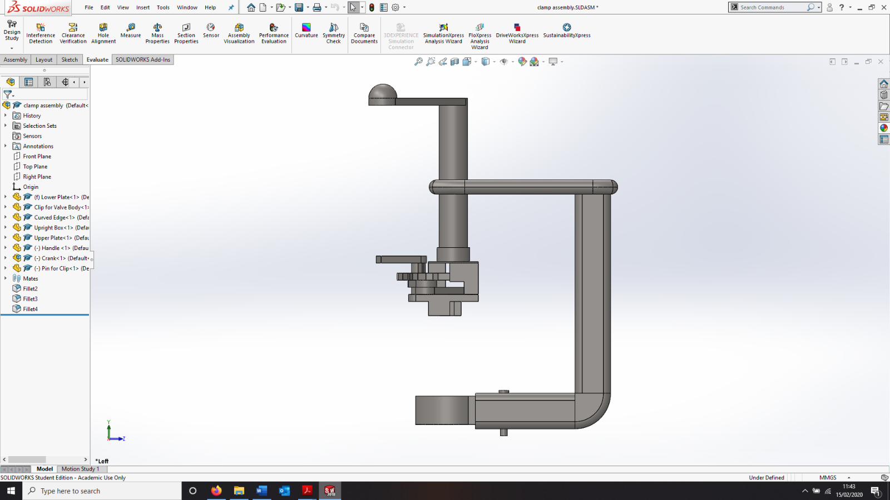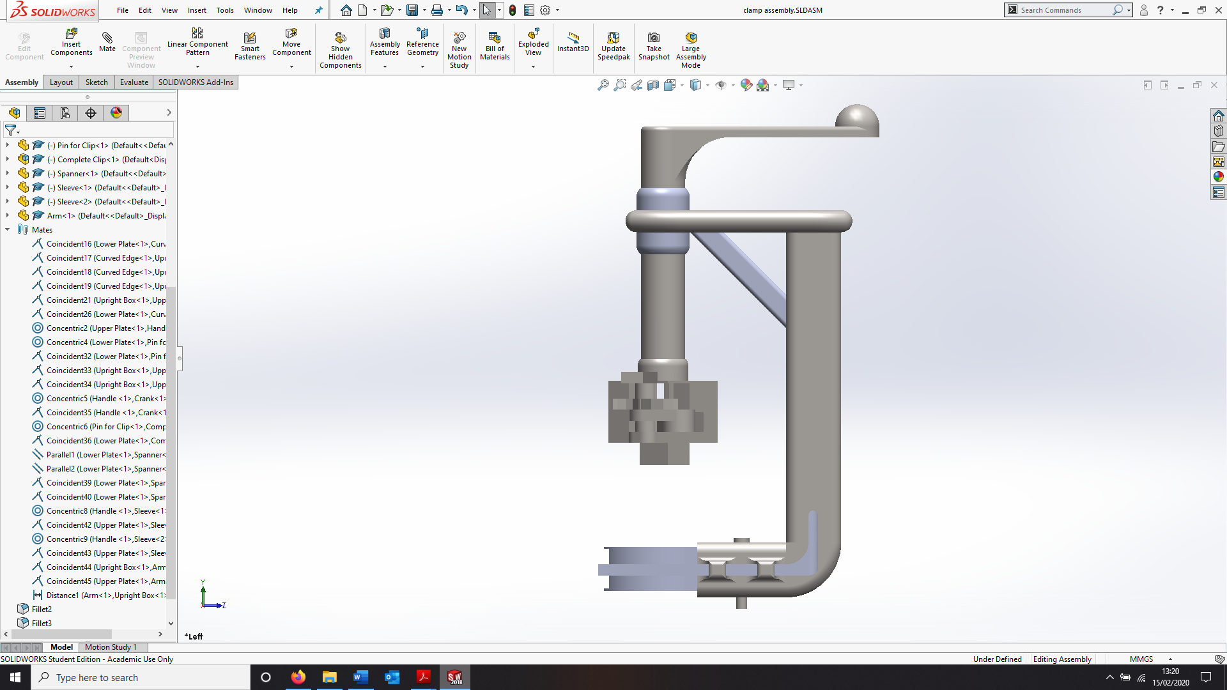

The second change is highlighted in orange and this is a bracing arm to improve the strength of the top of the product as it stops a large moment from being created and potentially snapping the product in half.

The third change is in blue and that was to fillet the edge of the handle to curve it, so it is more like a single part and less likely to snap in two.

Stability Improvements

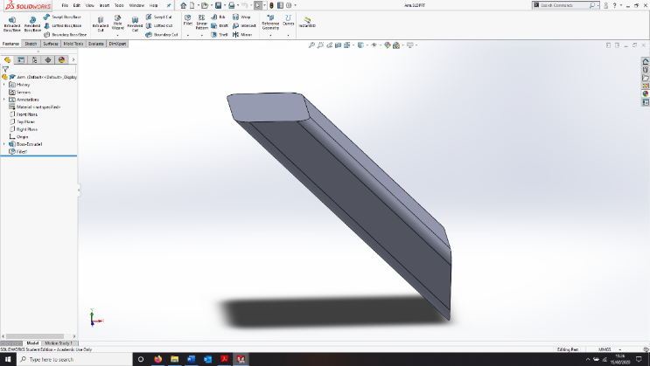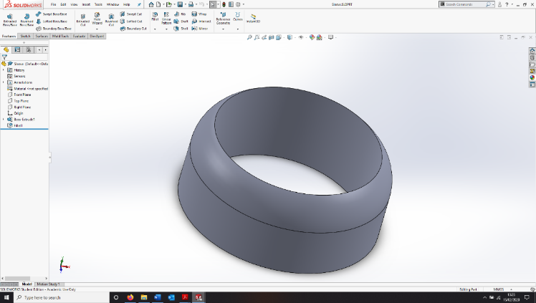

**Sleeve**

**Bracing Arm**

Several changes were made in order to improve the stability of the product. The first of which is highlighted using the green box, which is an added sleeve to further constrain the movement of the large shaft, in order to prevent rotation and ensure smooth up and down motion. Two of these parts are used in this design.

**After**

**Before**

The first change made in order to make the product smaller and therefore, cheaper and faster, to produce was to reduce the length of the clamp that holds the body of the valve by 10mm. Whilst this may not seem like a lot, this corresponds to a volume reduction of 12,000mm3 which is significant.

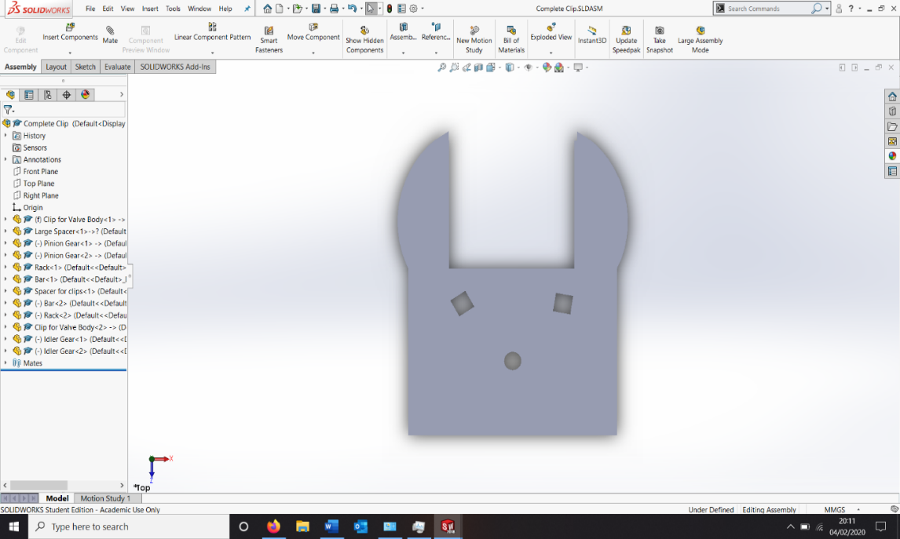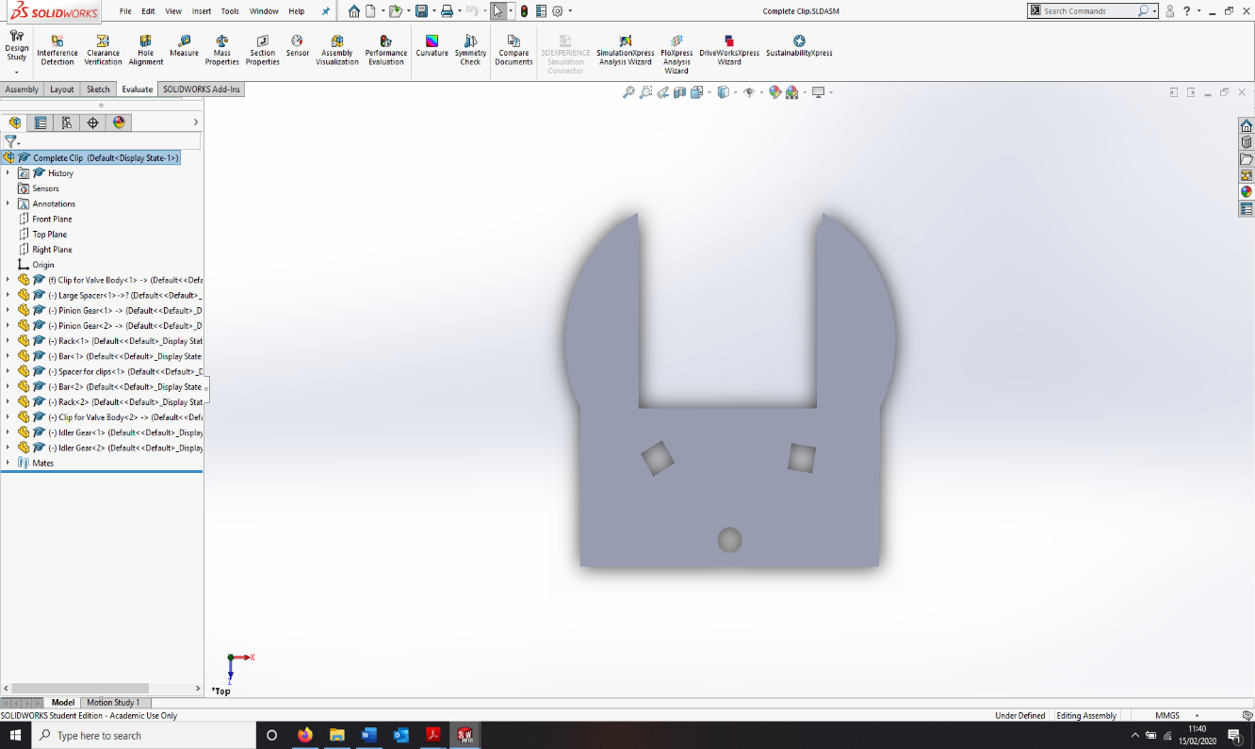

Miniaturisation

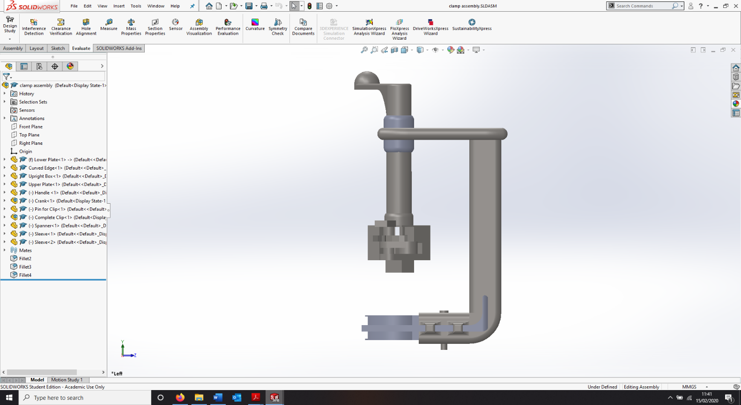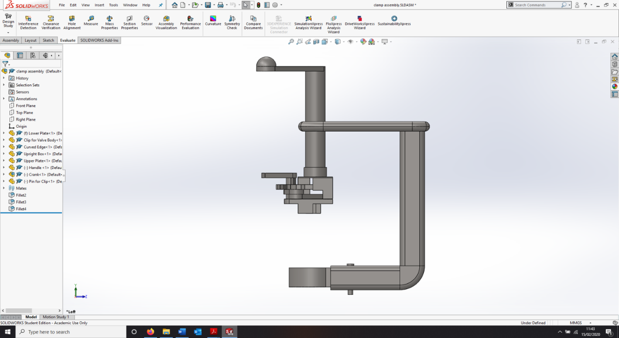

The final change was to reduce the length of the product itself by altering the dimensions show in red and reducing them by 30mm as this was redundant material that would have made the product harder to use as it could not fit in the smaller spaces that the product would need to be used in. This resulted in a volume reduction of approximately 38,700mm3 which is substantially greater than the first change.

After creating our metal model and completion of the further refinements, we decided we needed a complete model to test the adjustable head clamp in situ, we decided to go about this by creating a second model out of wood. We first created the handle by sanding the ends of two pieces of dowel rod down and gluing them together. Next, we created the main frame out of three box sections of wood and drilled a hole through the topmost one for the handle and stuck everything together using PVA and some panel pins.

The adjustable part we chose to test was the original design without the locking mechanism as we had already proven it worked through the use of an earlier plastic model and we did not feel the need to overcomplicate our model. This original design is pictured to the left.

Queen’s University kindly agreed to make up the adjustable mechanism out of MDF and one steel bar for us as shown below. It operates in exactly the same way as the original design and works as intended.

Wooden Model

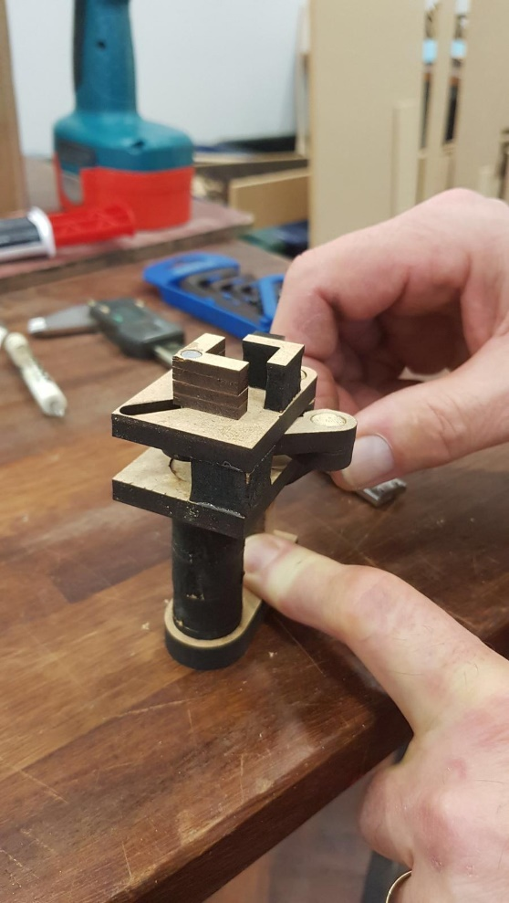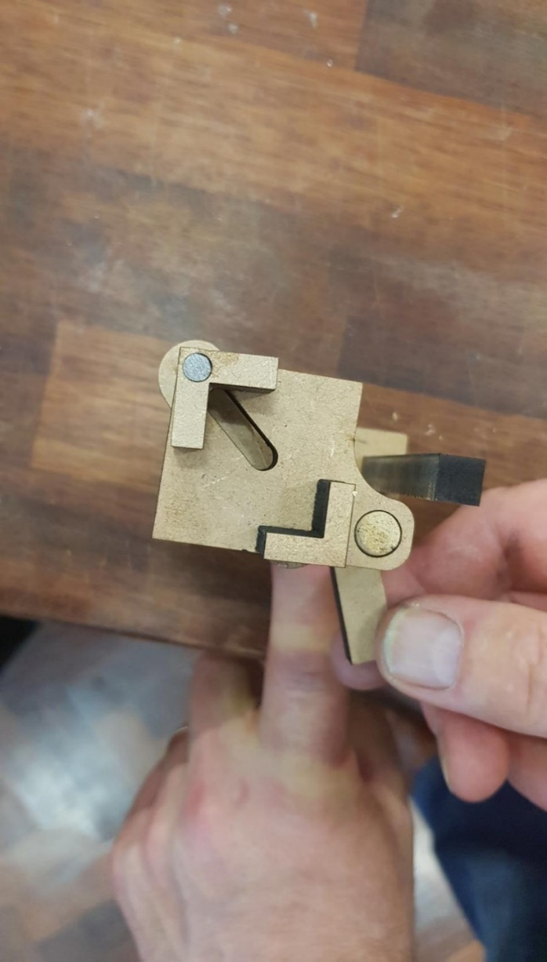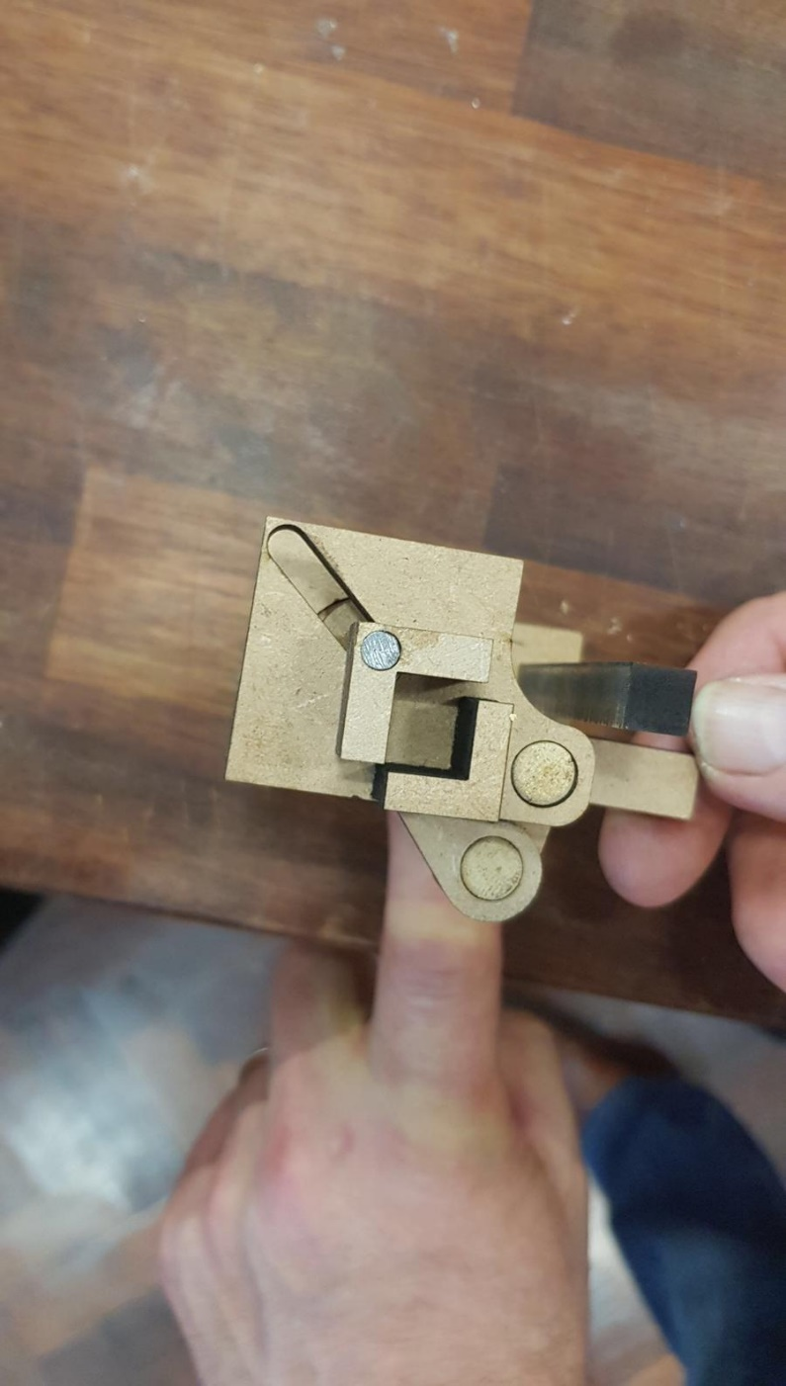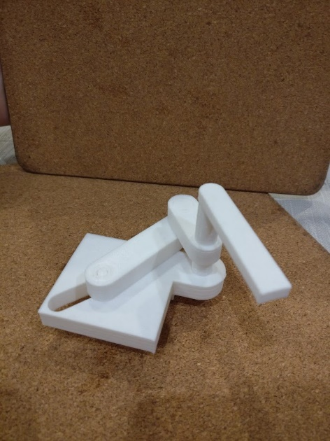

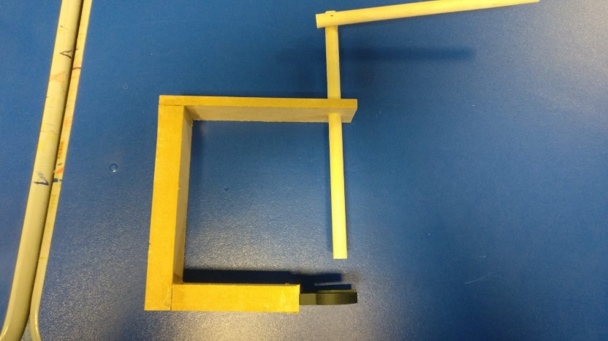

After our round of testing we found no further errors in our design as compared with the original metal model, so we decided to move to the production of a final plastic prototype which should allow us to identify any final issues within our design.

The frame we made is pictured to the right without the adjustable mechanism connected, this just shows how we connected up the box sections.

This final protype was created by 3D printing the main frame of the model and then recreating the two adjustable parts and joining them to that.

One issue we noticed during the final prototype was that the clamp to hold the body of the valve could not be made big enough to hold the valves that were made twenty years ago. To fix this, we need to increase the size of the movement of the rack and pinion setup by 5mm. This will be fixed in a future prototype.

Finally, as a group we would like to apologise for the lack of photos of the complete prototype. This is due to the model being in our school which, due to the ongoing Covid-19 pandemic, is currently unreachable for photographs. The model is complete, however if our group-time together had not been cut short by the Covid-19 pandemic, there are a few adjustments previously discussed that would have been implemented into the final prototype.

Final Prototype

# Bibliography

Layosa, C. (2018, March 7). *How to Convert from Rotary to Linear Motion*. Retrieved from Machine Design: https://www.machinedesign.com/automation-iiot/article/21836482/design-essentials-how-to-convert-from-rotary-to-linear-motion